IMPACTO ESPERADO DO EL NINO
O INAMET irá publicar no dia 30 de Setembro a previsao para os meses de Outubro, Novembro e Dezembro de 2026 e Janeiro, Fevereiro e Março de 2027 (Comunicado 004/INAMET/2026, de 15 de Agosto)

- IMPACTO ESPERADO DO EL NINO
Choque esperado
- Escasses de chuva
- Excesso de chuva
- Municipios de maior risco de excesso e escasses de chuva?
- Com base na previsao do INAMET

Agricultura
- Populacao que vive da agricultura (INE, RAPP)
- Areas perdidas – dados historicos
- Populacao que vive da pecuaria (INE, RAPP)
- Mortalidade de animais - dados historicos
- Doenças associadas a seca e excesso de chuva
- Municipios de maior risco/prioritarios?

Pessoas deslocadas e/ou migração
- Dados historicos de deslocados internos e migracao para Namibia
- Centros de acolhimento de deslocados
- Municipios de maior risco/prioritarios?

Educação
El Niño is likely to disrupt children’s access to education through both drought and flooding. Water shortages can increase the time children, particularly girls, spend collecting water, while food insecurity and loss of household livelihoods may increase absenteeism, school dropout and pressure on children to support household coping strategies. Flooding may also damage school infrastructure and prevent children from safely reaching schools. Recent floodings in Benguela April 2026 have shown the vulnerability, and damaged school infrastructure impacted more than 13,000 students. Last El Nino data
To reduce disruption, preparedness should focus on ensuring continuity of learning in affected areas, including through temporary learning spaces and pre-positioned learning materials. Expanding school feeding in vulnerable districts can also help protect children’s nutrition while supporting school attendance during periods of food insecurity.

Saude
Drought and flood exacatbated by El Nino are likely to increase health risks for children. In drought-affected areas, water shortages and reduced access to safe water can increase dehydration, illness and disease, while flooding may contaminate water sources and increase the risk of cholera, diarrhoeal diseases and malaria. At the same time, food insecurity and reduced agricultural and livestock production may increase the risk of acute malnutrition, particularly among young children. These pressures are likely to place additional strain on already vulnerable health services and communities.
Preparedness should therefore focus on maintaining access to essential health services in high-risk areas, including pre-positioning critical supplies, strengthening disease surveillance and deploying mobile health teams to vulnerable and hard-to-reach communities.

WASH
- Dados historicos sobre pessoas sem acesso a agua
- Distancias ate as fontes de agua, etc.
- Etc.
- Municipios de maior risco/prioritarios?
El Niño is likely to significantly affect access to safe water and sanitation, with drought reducing the availability of water in already water-stressed areas and flooding increasing the risk of contamination of water sources. These conditions can increase the risk of waterborne diseases, more time, in particular children and girls, spending more time collecting water, affecting their wellbeing.
Preparedness should focus on restoring critical non-functional water infrastructure, pre-positioning water treatment and storage supplies, and strengthening water quality monitoring and community-based water management.
Saude Reprodutiva
- Xxxx
- Dddd
- Fff
Segurança Alimentar
- Dados das analises IPC, populacao IPC Fase 3
- Municipios mais afectados - municipios na Fase 4
- Estimativas da populacao a ser afectada na base das principais fontes de renda, IPC, FIES, etc..
- Municipios de maior risco/prioritarios?

Nutrição

People in Need: 189,000
Target: 132.000
Requirements (USD): 1.3 M
Partners: 5 - UNICEF, WFP, World Vision, People in Need, For Afrika
Food insecurity and malnutrition rates in Angola are already high. With El Niño expected to further aggravate climatic shocks and disrupt livelihoods, the risk of acute malnutrition among children under five is likely to increase significantly.
Previous El Niño episodes, particularly those of 2012-2016, 2019, and 2023, had devastating humanitarian impacts across Angola. Prolonged drought conditions in the southern provinces of Huíla, Namibe, Cunene, and Cuando Cubango triggered a cascade of interconnected crises, including severe water shortages, widespread livestock losses, reduced agricultural production, heightened food insecurity, and increased rates of severe acute malnutrition.
These recurring climate shocks continue to undermine household resilience and exacerbate existing vulnerabilities. Crop failures and livestock stress directly reduce food availability and household income, driving higher levels of food insecurity and malnutrition, especially in southern Angola. The frequency and severity of these events underscore the urgent need to strengthen preparedness, enhance early response capacities, and build the resilience of vulnerable communities. Targeted investments are particularly critical to protect children under five years of age, as well as pregnant and breastfeeding women and girls, who face the greatest nutritional risks during climate-related emergencies.
Analysis of nutrition data from the multiple health indicators survey (IIMS 2023-24) and 2025 SMART surveys, indicates that the projected impact of El Niño on acute malnutrition will vary across provinces. While Huíla and Benguela are expected to have relatively low global acute malnutrition (GAM) prevalence rates, they are likely to account for a large number of affected children due to their sizeable populations and Luanda is projected to have the highest caseload of acute malnutrition, all three provinces are forecasted to have the GAM numbers increase driven by its population density and vulnerability to flooding. In contrast, Moxico, Lunda Norte, and Zaire are expected to have the highest GAM prevalence rates, although the total number of affected children will be comparatively lower. These findings highlight the need to consider both prevalence and caseloads when prioritizing nutrition interventions and resource allocation for El Niño preparedness and response.

Figure 1. Acute malnutrition prevalence and expected population to be affected, by province.
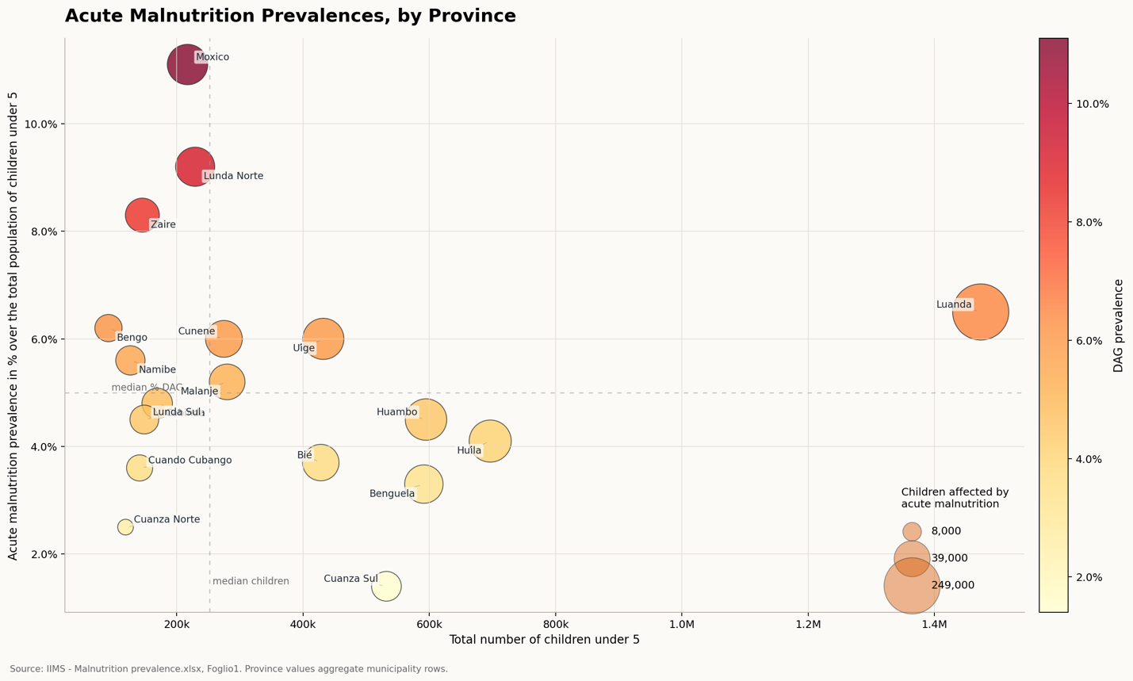
*The size of the dots indicate the increasing number of affected children. The intensity of the red colour is proportional to the increased prevalence in %.

Given the expectation of greater El Niño-related impacts in southern Angola, Figure 2 presents the estimated number of children affected by acute malnutrition alongside the projected prevalence rates in the four most affected municipalities across Benguela, Cuando Cubango, Cunene, Huíla, Moxico, and Namibe, highlighting areas with the highest nutrition needs and the greatest risk of humanitarian impact of El Niño in Angola.
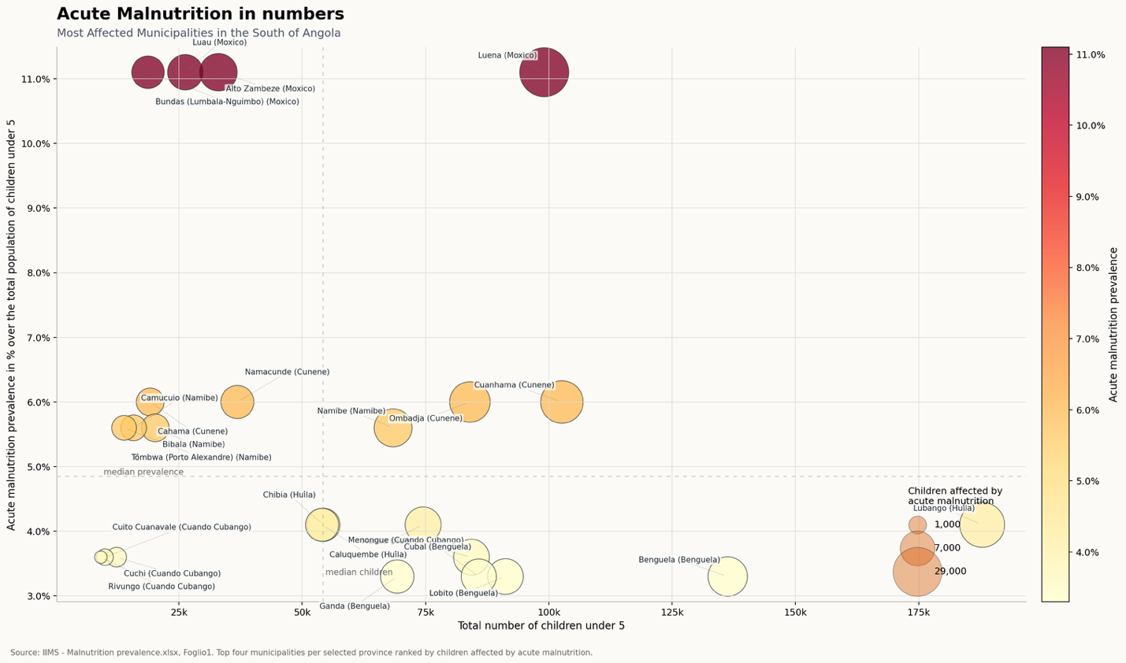

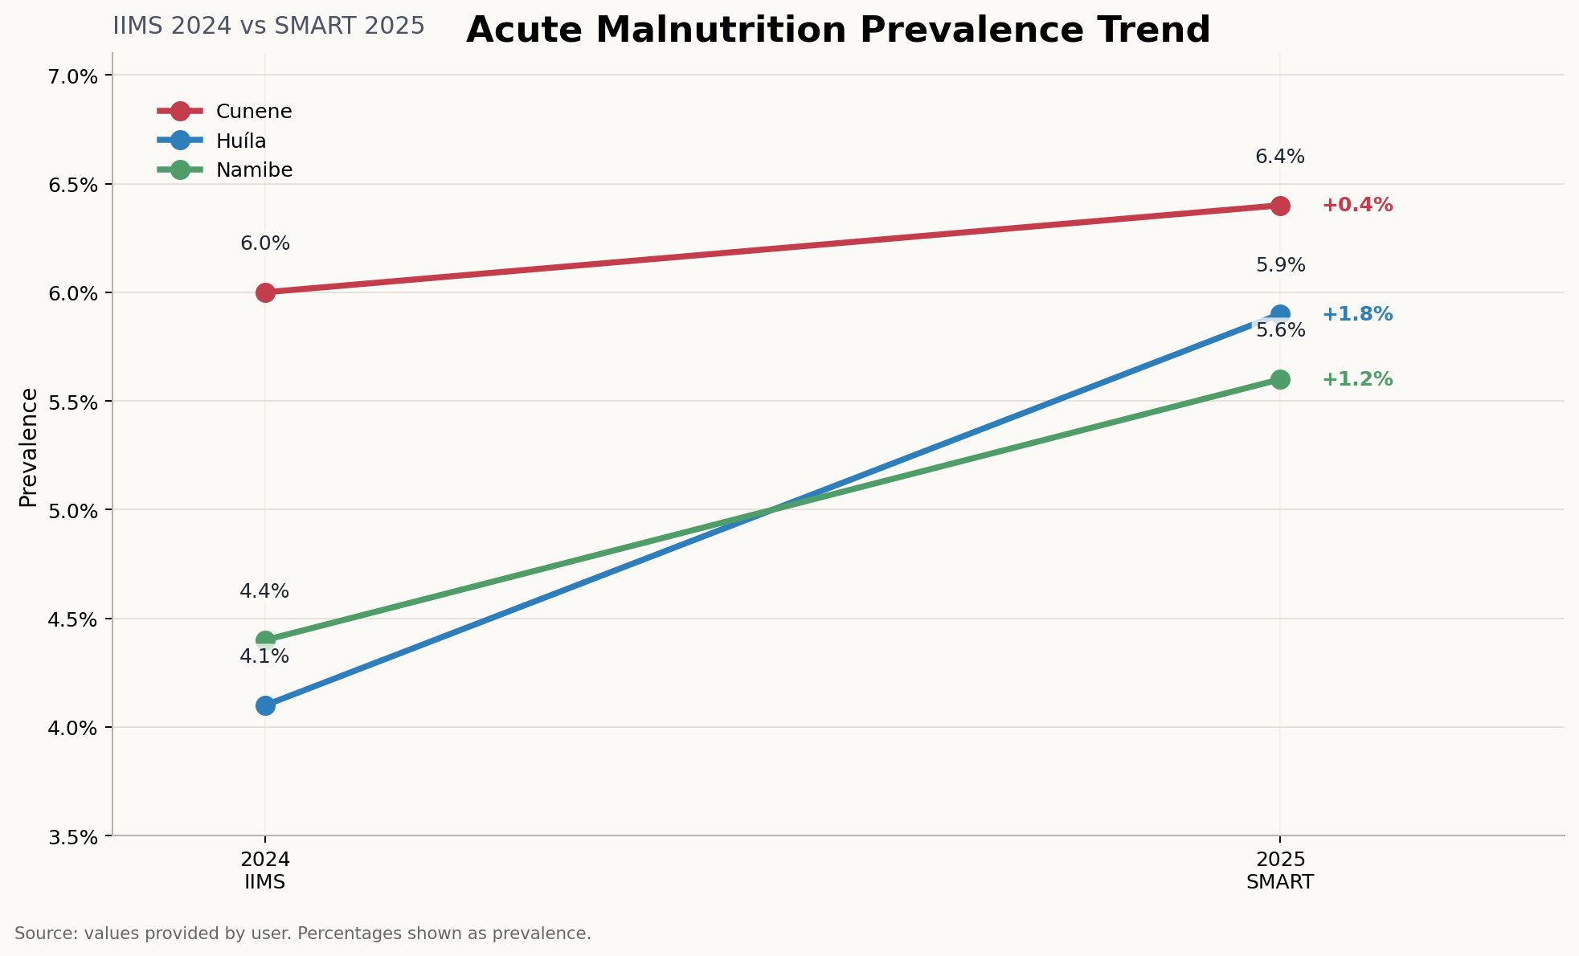
Figure 3: To provide a time-series, biannual comparison of the prevalence rates of acute malnutrition, this graph shows the increasing trends of acute malnutrition in Cunene, Huila and Namibe. The analysis compares data from 2024 (IIMS) and 2025 (SMART). Due to El Niño effect the indicator could worsen significantly due to a mix of heavy rains, floods, and droughts.

Table 1. The table showcase the data used in Figure 3
Prevalence of Acute Malnutrition in the Southern Belt of Angola
Province | Municipality | Estimated total number of children under 5 | Estimated Total Number of Children affected by acute malnutrition | Acute malnutrition prevalence
Moxico | Luena | 99058 | 28588 | 11%
Huila | Lubango | 187861 | 20026 | 4%
Cunene | Cuanhama | 102639 | 16012 | 6%
Cunene | Ombadja | 83980 | 13101 | 6%
Benguela | Benguela | 136254 | 11691 | 3%
Namibe | Namibe | 68410 | 9960 | 6%
Moxico | Alto Zambeze | 33002 | 9524 | 11%
Huila | Matala | 74505 | 7942 | 4%
Cuando Cubango | Menongue | 84295 | 7890 | 4%
Benguela | Lobito | 91200 | 7825 | 3%
Moxico | Luau | 26280 | 7584 | 11%
Benguela | Cubal | 85798 | 7361 | 3%
Benguela | Ganda | 69258 | 5942 | 3%
Huila | Chibia | 54280 | 5786 | 4%
Huila | Caluquembe | 54021 | 5759 | 4%
Cunene | Namacunde | 36841 | 5747 | 6%
Moxico | Bundas (Lumbala-Nguimbo) | 18720 | 5403 | 11%
Cunene | Cahama | 19176 | 2991 | 6%
Namibe | Bibala | 20183 | 2939 | 6%
Namibe | Camucuio | 15784 | 2298 | 6%
Namibe | Tombwa (Porto Alexandre) | 13884 | 2022 | 6%
Cuando Cubango | Cuchi | 12362 | 1157 | 4%
Cuando Cubango | Cuito Cuanavale | 10015 | 937 | 4%
Cuando Cubango | Rivungo | 9153 | 857 | 4%
 | Total | 1406959 | 189342 | 6%

The 2025 SMART surveys also highlighted a persistent and critical burden of chronic malnutrition in Angola. Stunting prevalence remains well above the WHO/UNICEF critical threshold of 30% in Huíla, Cunene, and Namibe, indicating a severe and longstanding public health concern coming from the IIMS 2015-16 and the IMMS 2023-24. The highest prevalence of stunting was recorded in Huíla at 61.1% (53.7-68.1), followed by Cunene at 49.2% (43.9-54.4) and Namibe at 42.4% (37.7-47.2). These findings indicate that nearly half, and in some cases more than half, of children in these provinces are affected by chronic undernutrition. This underscores the urgent need for sustained, multi-sectoral interventions to address the underlying causes of stunting and improve dietary diversity, meal frequency, and appropriate infant and young child feeding practices among children aged 6-59 months. Such efforts are particularly critical in climate-vulnerable areas, where recurrent shocks and emergencies further exacerbate food insecurity, undermine caregiving and feeding practices, and increase the risk of poor nutrition outcomes.
Previous Food Security and Nutrition Assessment (AVSAN 2025) that was the basis for the IPC Acute Malnutriiton. In the analysis a total of xxxx municipalities were classified as IPC 3.
A situação actual refere-se ao período de Agosto a Novembro de 2024. Dos 31 municípios analisados, a desnutrição aguda foi classificada em Crítica (Fase 4 de IPC DA) nos seguintes 6 municípios: Benguela, Chongoroi e Ganda, da província de Benguela, Cuvelai e Curoca, da província do Cunene e Tombwa da Província do Namibe. Em 3 municípios, Cuchi e Menongue da Província de Cuando Cubango e Chicomba (Huíla) , a desnutrição aguda foi classificada em Séria (Fase 3 de IPC DA) e em 15, especificamente: Cuito Canavale (Cuando Cubango), Cahama, Cuanhama, Namacunde, Ombadja, pertencentes à província do Cunene, Chibia, Gambos e Jamba, da província da Huíla, Bundas, Luchanzes e Alto Zambeze, pertencentes à província do Moxico e Camucuio, Bibala, Moçâmedes e Virei da província do Namibe a situação foi classificada em Alerta (Fase 2 de IPC DA). Os restantes municípios foram classificados em Aceitável (Fase 1 de IPC DA).
Espera-se que a situação nutricional possa manter-se similar em todos os 6 municípios em que desnutrição aguda foi classificada em Crítica (Fase 4 da IPC DA) no período de Agosto a Novembro de 2024 e os 3 que a desnutrição aguda foi classificada como Séria (Fase 3 da IPC DA). Dos 15 municípios em que a desnutrição aguda foi classificada em Alerta (Fase 2 da IPC DA), 6 poderão sofrer uma alteração de Fase, passando a desnutrição aguda a ser classificada em Séria (Fase 3 da IPC DA), nomeadamente: Virei, Bibala e Camucuio (na provóncia do Namibe), Luchanzes e Bundas (na província do Moxico) e Cahama (na província do Cunene).

Table 2. Food security and nutrition status in the most affected provinces

Province | Stunting | Severe Food Insecurity (2023) | Moderate Food Insecurity  (2023)
Province | % U5 | % Households
Bengo | 44 | 14.4 | 78.8
Cuanza sul | 53 | 8.2 | 50.7
Benguela | 44 | 14.8 | 62.3
Namibe | 44 | 33.8 | 50.1
Huila | 47 | 16.5 | 57.4
Cunene | 40 | 7.2 | 60.0
Cuando Cubango | 38 | 47.4 | 47.0
Sources: IIMS 2023/2024, FIES 2023.
Preparedness should focus on GIDA training for health workers and RCCE of nutrition for early identification of sign and symptoms of acute malnutrition, in addition to pre-positioning of essential nutrition supplies, including Ready-to-Use Therapeutic Food (RUTF), Ready-to-Use Supplementary Food (RUSF) and Therapeutic milks F-75 and F-100, while strengthening nutrition screening capacity, referral and treatment services in vulnerable and hard-to-reach communities.

Cross cuting
- Género, deficiência e inclusão
Drought and flood conditions are likely to disproportionately affect women, girls and persons with disabilities, exacerbating existing vulnerabilities and inequalities. Women and girls may face increased time spent collecting water, reduced access to education and livelihoods, and heightened risks of gender-based violence, exploitation and early marriage as households adopt negative coping mechanisms. Persons with disabilities may face additional barriers accessing water, health care, education and humanitarian assistance, particularly where infrastructure, information and emergency services are not fully accessible. Children with disabilities are also at greater risk of exclusion from essential services during droughts, floods and displacement. Population movements driven by drought, loss of livelihoods and water scarcity may further increase protection risks for female-headed households, children and persons with disabilities.
Preparedness and response efforts should therefore ensure that assistance, information and services are accessible, inclusive and responsive to the specific needs of vulnerable groups.

- ESTIMATIVAS DE PESSOAS AFECTADAS
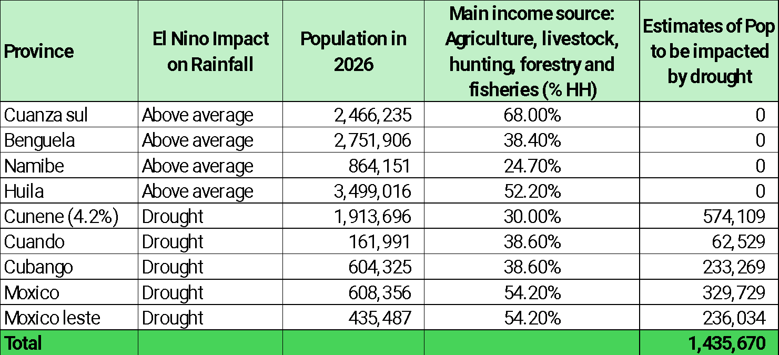

- RECOMENDACOES DE RESPOSTA IMEDIATA
- Mudança social e comportamental

Distribuicao de tarefas
Sector | Lider | Task force
Agricultura | FAO: Fatima | WFP
Deslocados | IOM
Educacao | UNICEF: Vatileny
Saude | WHO
WASH | UNICEF: Ida-Marie | ForAfrika
Saude reprodutiva | FNUAP: Luis Samacumbi
Seguranca alimentar | WFP: Paulo | WV, PIN
Nutricao | UNICEF: Joana | WFP, ForAfrika, WV
Areas transversais - genero | Maria Casal??
Areas transversais – deficiencia e inclusção | UNICEF: Teresa Fedão

Em Angola, o El Nino afecta a precipitacao de duas formas, a zona sudeste recebe chuvas abaixo do normal enquanto a zona sudoeste regista chuvas acima do normal. A seca do sul de Angola resulta em altos niveis de insegurança alimentar porque maior parte dos agregados familiares vive da actividade agrícola e/ou pecuária. Uma análise da Insegurança Alimentar Aguda feita em 2021 em 17 municípios das províncias de Namibe, Huila e Cunene classificou seis municípios na Fase 4 e outros 10 na Fase 3 da IPC.
Como resultado da severidade da insegurança alimentar aguda em 2021:
- Houve pessoas deslocadas internamente e criados centros de deslocados nos municípios de Cahama e Curoca,
- Houve pessoas que se deslocaram a Namibia,
- Devido as deslocações, crianças perderam o ano lectivo,
- Houve mortalidades significativas em bovinos por falta de água e pasto.
- Houve cerca de 114.000 crianças menores de 5 anos com desnutrição aguda.
- 1,3 milhões de pessoas na Fase 3+ da IPC insegurança alimentar aguda.
Para a próxima época chuvosa preve se que o El Nino seja severo e poderá afectar significativamente a produção agrícola e pecuária nas regiões onde haverá seca e chuvas muito acima do normal que causem cheias ou inundações. Em regiões com muita precipitação espera se que haja aumento de casos de desnutrição aguda e risco de eclosão de doenças como a cólera com a deterioração do saneamento do meio.

Expected Impact of El Nino
In Angola, El Niño affects rainfall in two ways: the southeastern region receives below-normal rainfall, while the southwestern region experiences above-normal rainfall. The drought in southern Angola results in high levels of acute food insecurity because the main livelihood activities is agriculture and and/or livestock. An analysis of Acute Food Insecurity conducted in 2021 in 17 municipalities of Namibe, Huila, and Cunene provinces classified six municipalities in Phase 4 and other 10 in Phase 3.
As a result of the severity of acute food insecurity in 2021:
- There were internally displaced people, and IDPs centers were created in the municipalities of Cahama and Curoca,
- People migrated to Namibia,
- Due to displacement, children missed the school year,
- A significant number of cattle died due to lack of water and pasture,
- Approximately 114,000 children under 5 with acute malnutrition,
- Around 1.3 million people in IPC Phase 3+.
For the next rainy season (2026-2027), El Niño is predicted to be severe and will significantly affect agricultural and livestock production in regions that will receive below average rainfall and above normal rainfall causing floods. Excessive rainfall will also increase acute malnutrition cases and the likelihood for cholera outbreak due to deterioration of sanitation conditions.

